1. Classes and Objects are basic building-blocks in Object-Oriented Paradigm or Object-Oriented Style.
2. **Class**:
   1. Blueprint = Design
   2. It represents a set of attributes (Variables) and behaviors (methods).
   3. Everything in terms on classes and objects.
3. **Example**: Let’s take a real life example (Use-Case).
   1. Architect 🡪 Planning 🡪 Residential Colony.
   2. Architect will create plan = design = blueprint, then the builder will start building the colony as per that blueprint.
   3. So class = Prototype = Sketch = Design.
   4. Design contains all the details such as of
      1. Garden.
      2. Departmental Store.
      3. Club House.
   5. So, the builder can create the same colony in different cities using the same design.  
      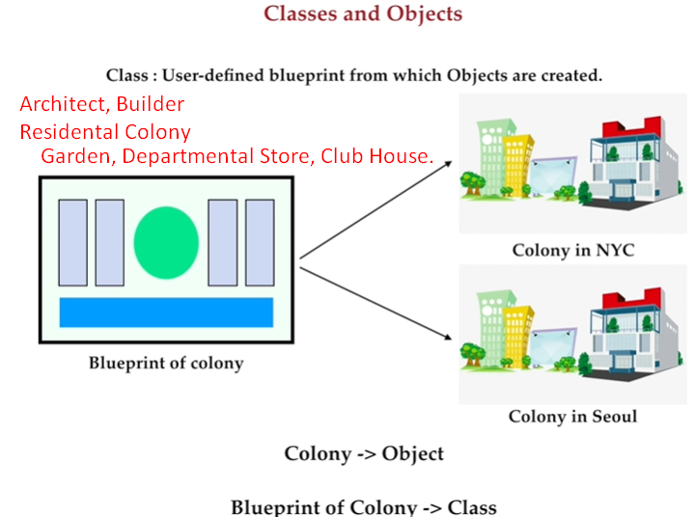
4. Blueprints are divided further.
5. Let’s try to crystal-clear.
   1. d
   2. In this world, everything is object-oriented.
   3. See around yourself; try to objectify the things in your mind. Think of their state & behaviors.
   4. So, everyone’s perspective of evaluating states and behaviors of the same object can be slightly different.   
      But it depends on your **programmatic requirement**.
   5. 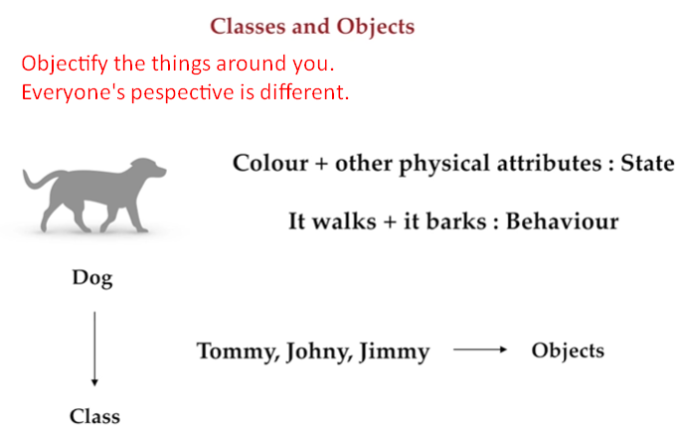
6. Let’s go to Code.
7. 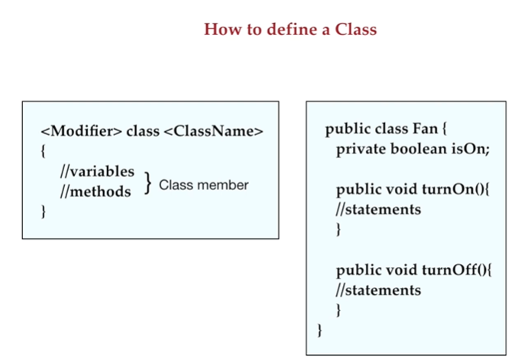
8. 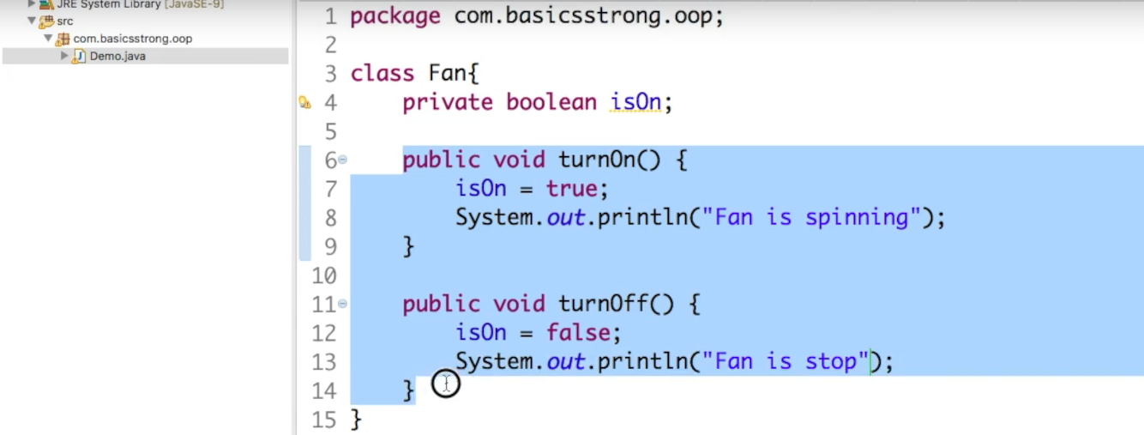
9. 